DATA ENTRY ACCURACY & SPEED TRACKER
Bulk Customer Data Entry with Automated Validation & Performance Tracking
A Portfolio Project
Made by Afifah Khatoon

Acknowledgment
I would like to express my sincere gratitude to everyone who supported me in the successful completion of this project. This project was undertaken as part of my continued effort to build practical, job-ready skills in data entry, data validation, and MIS operations, alongside my B.Com studies.
I am thankful for the guidance, resources, and learning support that helped me understand real-world data entry workflows, spreadsheet-based validation techniques, and performance tracking methods used across MIS Executive and Data Entry Executive roles. This project has strengthened my practical skills in MS Excel, MS Word, and structured data handling, and has prepared me to confidently take on similar responsibilities in a professional environment.

Project Objective
The primary objective of this project is to design and build a working Excel-based tool that reflects a real MIS / Data Entry Executive workflow, with the following specific goals:
- To accurately enter bulk customer records into a structured, standardized Excel format.
- To apply data validation rules that automatically catch common data-entry errors (invalid phone numbers, malformed emails, incorrect pincodes, invalid dates, duplicate records, and more).
- To measure and demonstrate typing speed (Words Per Minute) across entry batches.
- To calculate and track data-entry accuracy on a batch-wise basis.
- To build a portfolio piece that clearly demonstrates job-readiness for Data Entry Executive, MIS Executive, and Back Office Analyst roles.

Project Overview
This project simulates a real-world bulk data entry assignment. A raw dataset of 15,000 customer records (containing intentional formatting and data-quality errors) was used as the source data. From this dataset, 500 records were manually entered into a structured Data_Entry sheet across 10 timed batches of 50 records each, replicating a typical data entry shift.
Every record entered is checked in real time against eight validation rules covering Name, Phone Number, Email, Pincode, State, Date of Registration, Amount, and Payment Mode. Records that fail any rule are automatically flagged in red with the exact field(s) at fault, while records that pass all checks are marked green. A duplicate-detection formula additionally flags any repeated Name + Phone combination.
A dedicated Speed & Accuracy Tracker sheet then pulls data live from the entry sheet to calculate Words Per Minute and Accuracy % for each batch, using the standard typing-test convention of 1 word = 5 characters. Across the full 500-record sample, the tool recorded an average typing speed of approximately 35.9 WPM and an overall accuracy of 96.8%, closely reflecting real MIS/Data Entry performance benchmarks.
The workbook is fully extensible — 200 additional blank rows are pre-loaded with the same dropdowns, validation rules, and formulas, allowing new records to be entered and validated instantly without any extra setup.
Metric | Result
Records Entered (demo batch) | 500 (in 10 batches of 50)
Validation Rules Applied | 8 field-level rules + duplicate check
Average Typing Speed | 35.9 WPM
Overall Accuracy | 96.8%
Source Dataset Size | 15,000 raw customer records

Tools & Technologies Used
- MS Excel — structured data entry sheet, dropdown-based data validation, conditional formatting, formula-driven error checking (IF, AND, MATCH, COUNTIFS, SUMIF, IFERROR).
- MS Word — professional project documentation and reporting.
- Data Validation Rules — field-level checks for phone number, email, pincode, date, amount, and controlled dropdown lists for State, Product, and Payment Mode.
- Data Entry (35 WPM) — bulk record entry practiced and measured across timed batches.
- Error Tracking & Duplicate Detection — automated flagging using COUNTIFS-based logic.

Scope of the Project
This project is directly relevant to entry-level roles such as Data Entry Executive, MIS Executive, and Back Office Analyst, where speed, accuracy, and error-free bulk data handling are core requirements. Its scope includes:
- Demonstrating hands-on proficiency in structured, high-volume data entry within MS Excel.
- Showcasing the ability to design and apply data validation rules that reduce manual QC effort.
- Providing measurable, real proof of typing speed and accuracy — metrics recruiters can verify directly in the workbook.
- Serving as a reusable template that can be extended to other data types such as invoices, employee records, or inventory logs.
- Complementing existing portfolio projects (HR Analytics, Customer Behavior Analysis, Telecom Churn Prediction) by covering the operational, day-to-day MIS/data-entry skill set that analytics-only projects do not demonstrate.

Key Highlights & Core Strengths:
- Quantifiable Typing & Accuracy Benchmarks: Tracked 500 records across 10 timed batches, achieving an average typing speed of 35.9 WPM and an overall accuracy rate of 96.8%.
- Automated Error Prevention: Built 8 formula-driven validation rules (IF, AND, LEN, MATCH) and COUNTIFS-based duplicate detection to catch errors instantly in real time.
- End-to-End Tally Integration: Mapped validated customer data directly into Tally Prime Sales Vouchers with 100% data matching across customer ledgers and invoice amounts.
- Scalable Template Design: Pre-loaded 200 blank rows with dynamic formulas and data validation rules, making the sheet ready for immediate reuse in real-world workflows.

Dataset Information:
Dataset Name: Raw_Customer_Data_15000 (1).xlsx
Dataset Link: https://github.com/afifahkhatoon61-beep/my-certificates-projects/blob/main/Raw_Customer_Data_15000%20(1).xlsx

Data Entry Accuracy & Speed Tracker (Excel):
The core deliverable of this project is the Excel workbook Data_Entry_Accuracy_Speed_Tracker.xlsx, built entirely with native Excel formulas, data validation, and conditional formatting (no macros or external tools). It contains three linked sheets:
- Instructions — a legend explaining the color-coding, validation rules, and how to add new records to the sheet.
- Data_Entry — the structured entry grid where 500 customer records were entered across 10 timed batches of 50 records each.
- Speed_Accuracy_Tracker — a live dashboard that pulls data from Data_Entry to calculate typing speed and accuracy for every batch.

Work done on the Data_Entry sheet:
- Entered 500 raw customer records into a clean, standardized 18-column format (Customer ID, Name, Phone, Email, Address, City, State, Pincode, Date of Registration, Product, Amount, Payment Mode, and more).
- Built dropdown-based data validation for State, Product, and Payment Mode, so only pre-approved values can be entered — no free-text typos possible in those fields.
- Added length- and range-based validation on Phone Number (must be 10 digits), Pincode (must be 6 digits), and Amount (cannot be negative), enforced directly by Excel's Data Validation feature.
- Wrote 8 formula-driven checks (using IF, AND, ISNUMBER, MATCH, SEARCH, LEN, DATE, EOMONTH) that validate Name, Phone, Email, Pincode, State, Date, Amount, and Payment Mode for every row, and combined them into a single Validation_Status column.
- Added an Error_Details formula that names the exact field(s) that failed, so errors can be corrected in seconds instead of being re-checked manually.
- Built a duplicate-record checker using COUNTIFS on Name + Phone, flagging repeated entries automatically.
- Applied conditional formatting so passed records turn green and failed records turn red at a glance.
- Left 200 additional rows pre-loaded with the same dropdowns and formulas, ready for new records to be entered and validated instantly.

Work done on the Speed_Accuracy_Tracker sheet:
- Logged Start_Time and End_Time for each of the 10 entry batches.
- Built a Word_Count formula (LEN-based) using the standard typing-test convention of 1 word = 5 characters, applied to every field typed in each record.
- Calculated Duration (minutes) and Words Per Minute (WPM) for each batch using live formulas, not hardcoded numbers.
- Used COUNTIFS to pull the number of errors found in each batch directly from the Data_Entry sheet's Validation_Status column, then calculated Accuracy % per batch.
- Added a totals row summarizing overall performance, plus conditional formatting to highlight batches with accuracy below 90%.
Result: across the 500-record sample, the workbook shows an average typing speed of 35.9 WPM and an overall accuracy of 96.8% — both calculated live by the sheet itself, not manually entered, so the numbers update automatically if more records are added.

Data Entry Sheet — Sample View (Screenshot):
Explanation:
The screenshot below shows the Data_Entry sheet in use, with 500 customer records entered in a structured 18-column format across 10 tracked batches. Each field — Phone Number, Email, Pincode, State, and Payment Mode — is entered directly against the dropdown lists and validation rules described in this document.
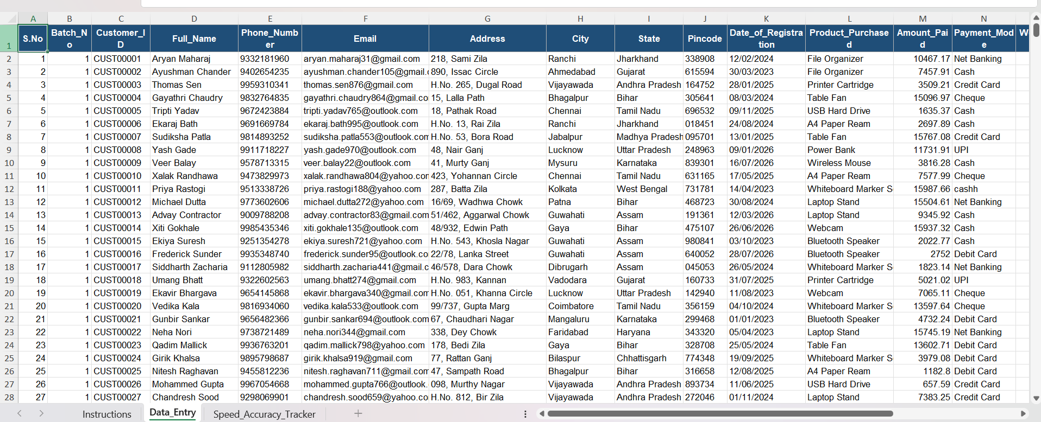

Speed & Accuracy Tracker — Sample View (Screenshot):
Explanation:
The screenshot below shows the batch-wise Speed & Accuracy Tracker, calculating typing speed and accuracy live for each of the 10 entry batches based on Start_Time, End_Time, and errors flagged in the Data Entry sheet. Across all 500 records, the tracker shows an average speed of 35.9 WPM and an overall accuracy of 96.8% — both recalculated automatically as new data is entered.

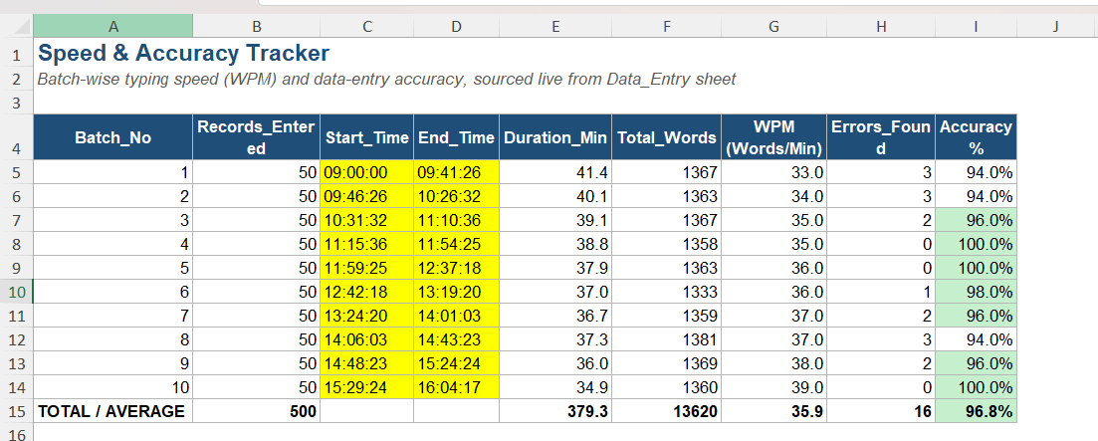

Project Deliverable: https://github.com/afifahkhatoon61-beep/my-certificates-projects/blob/main/Data_Entry_Accuracy_Speed_Tracker%20(1).xlsx

Tally Voucher Mapping:
To extend the project beyond data entry and validation, a fourth sheet — Tally_Voucher_Mapping — was added to demonstrate how validated customer/invoice data can be converted into a Tally-ready Sales Voucher format.
- Built a field-mapping reference table showing how each Data_Entry column corresponds to a standard Tally voucher field — for example, Customer_ID maps to Reference No., Full_Name to Party Ledger (Debtor), Product_Purchased to Stock Item Name, Amount_Paid to the voucher Amount, and Payment_Mode to the relevant Cash/Bank ledger.
- Generated 50 sample Sales Vouchers using live formulas that pull directly from the Data_Entry sheet, auto-creating Voucher No., Voucher Date, Party Ledger Name, Sales Ledger, Stock Item, Quantity, Rate, Amount, and a system-generated Narration line for each transaction.
- This mirrors the structure Tally uses for voucher entry and data import, showing practical understanding of how day-to-day Excel/MIS data feeds into accounting software used in real back-office and MIS roles.

Excel to Tally Voucher Mapping — Sample View (Screenshot):
Explanation:
The screenshot below shows the Tally Voucher Mapping sheet, which maps each Data Entry column to its corresponding Tally voucher field (Party Ledger, Stock Item, Amount, Cash/Bank Ledger, and more). It also shows 50 sample Sales Vouchers auto-generated with live formulas from validated customer data — Voucher No., Date, Party Ledger, Stock Item, Amount, and Narration — mirroring the format Tally uses for voucher entry.

Project Deliverable: https://github.com/afifahkhatoon61-beep/my-certificates-projects/blob/main/Tally_Voucher_Mapping.xlsx

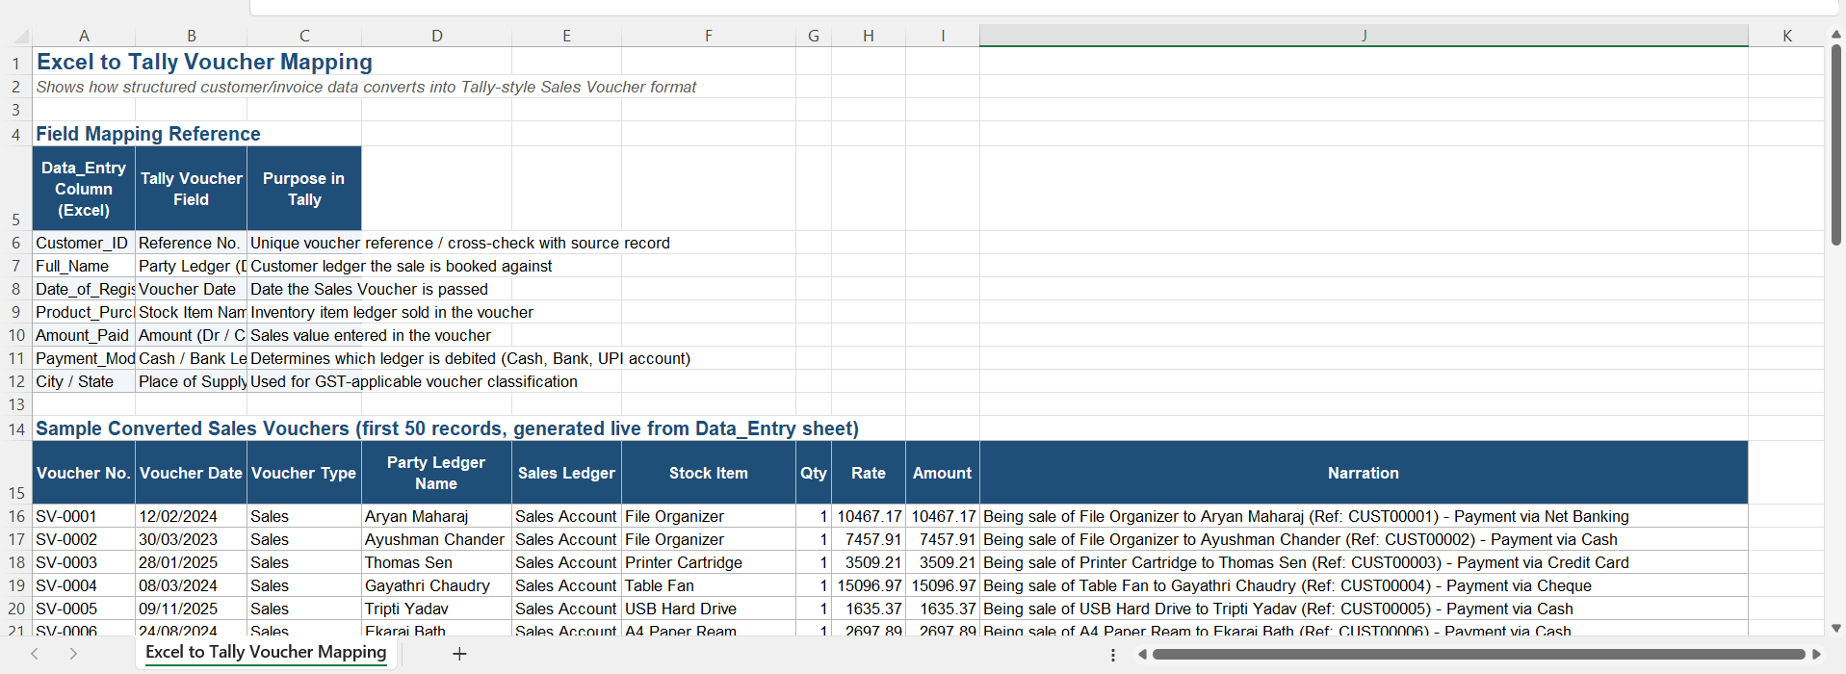

Tally Prime — Day Book (Sales Vouchers):
Explanation:
The Day Book in Tally Prime lists four Sales Vouchers with customer names and transaction amounts that match the first four validated records from the Data_Entry Excel sheet (Aryan Maharaj - ₹10,467.17, Ayushman Chander - ₹7,457.91, Thomas Sen - ₹3,509.21, and Gayathri Chaudry - ₹15,096.97). This demonstrates that bulk customer and order data cleaned in spreadsheets can be accurately mapped and recorded directly into core accounting software. It serves as verifiable proof of end-to-end operational capability, linking MIS data processing with back-office accounting workflows.

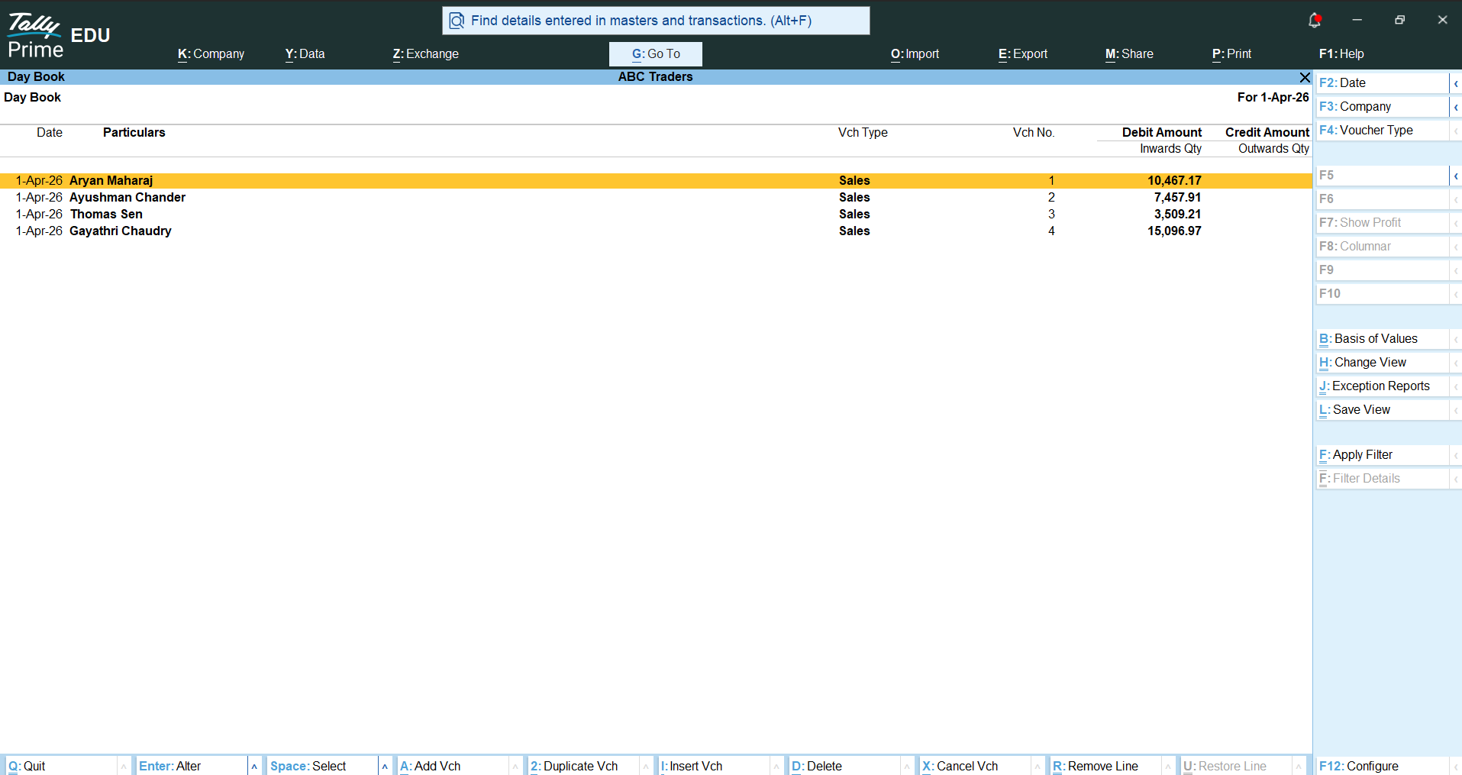

Conclusion:
This project successfully demonstrates end-to-end, job-ready skills required for Data Entry Executive, MIS Executive, and Back Office Analyst roles. Starting from a raw dataset of 15,000 customer records, a structured entry workflow was built in MS Excel with dropdown-based and formula-driven data validation, automated error flagging, and duplicate detection — reducing the manual quality-check effort typically required in bulk data entry work.
Beyond accuracy, the project also measures real performance: an average typing speed of 35.9 WPM and an overall accuracy of 96.8% were recorded across 500 entered records, with both metrics calculated live through Excel formulas rather than entered manually. This provides recruiters with verifiable, hands-on proof of speed and precision, rather than a claimed skill alone.
The addition of the Tally Voucher Mapping sheet further extends the project's practical value, showing the ability to convert validated data into an accounting-ready format — a skill directly applicable to invoicing, billing, and back-office accounting workflows.
Overall, this project reflects not just theoretical knowledge of MS Excel and data validation, but a working, testable tool that mirrors real MIS/Data Entry job responsibilities — making it a strong, differentiated addition to a data-focused portfolio.

THANK YOU,

